Neoclassical Realism Goes South: Diffusion, Adaptation, and the Global South Uptake of NCR

Abstract

Neoclassical Realism (NCR) has consolidated itself as a widely used IR Theory over the past decades. Yet its diffusion and the ways scholars repurpose it across contexts remain underexplored. This article argues that, despite its canonical formulation by scholars largely based in Europe and the United States, NCR has become a “working theory” for Global South research agendas. Its appeal lies in analytical flexibility: NCR accommodates diverse variables and legitimizes explanations that connect systemic incentives to domestic constraints – an especially useful move where foreign policy outcomes are jointly shaped by external pressures and domestic politics. We show it by surveying 349 journal articles indexed by Scopus or Web of Science published between 1998 and 2025, combining statistical and text-as-data techniques. Our findings show that NCR became frequently used by Global South scholars rather than Global North researchers. We also find regional variation in how authors operationalize NCR. This suggests adaptation rather than simple theoretical replication, denoting that flexibility has been a key element of NCR's appeal. These results help understand how IR theories travel, why flexibility facilitates theory uptake, and what NCR’s trajectory reveals about the evolving foundations and internationalization of Global South IR scholarship(s).

Keywords: Neoclassical Realism; IR Theory; Scientometrics; Global IR

Introduction

Neoclassical realism has traveled farther than its architects could anticipate, and what it became along the way has gone largely unexamined. Since Gideon Rose (1998) coined the term, NCR has expanded from a cluster of North American foreign policy studies into a recognizable global research program, generating scholarship across Europe, Asia, the Middle East, Latin America, and Africa (Foulon and Meibauer 2020). From 1998 to 2025, more than 350 articles deploying or examining the framework have appeared in indexed journals with an exponential increase over the past decade, as shown in Figure 1.

Figure 2 – Yearly Production
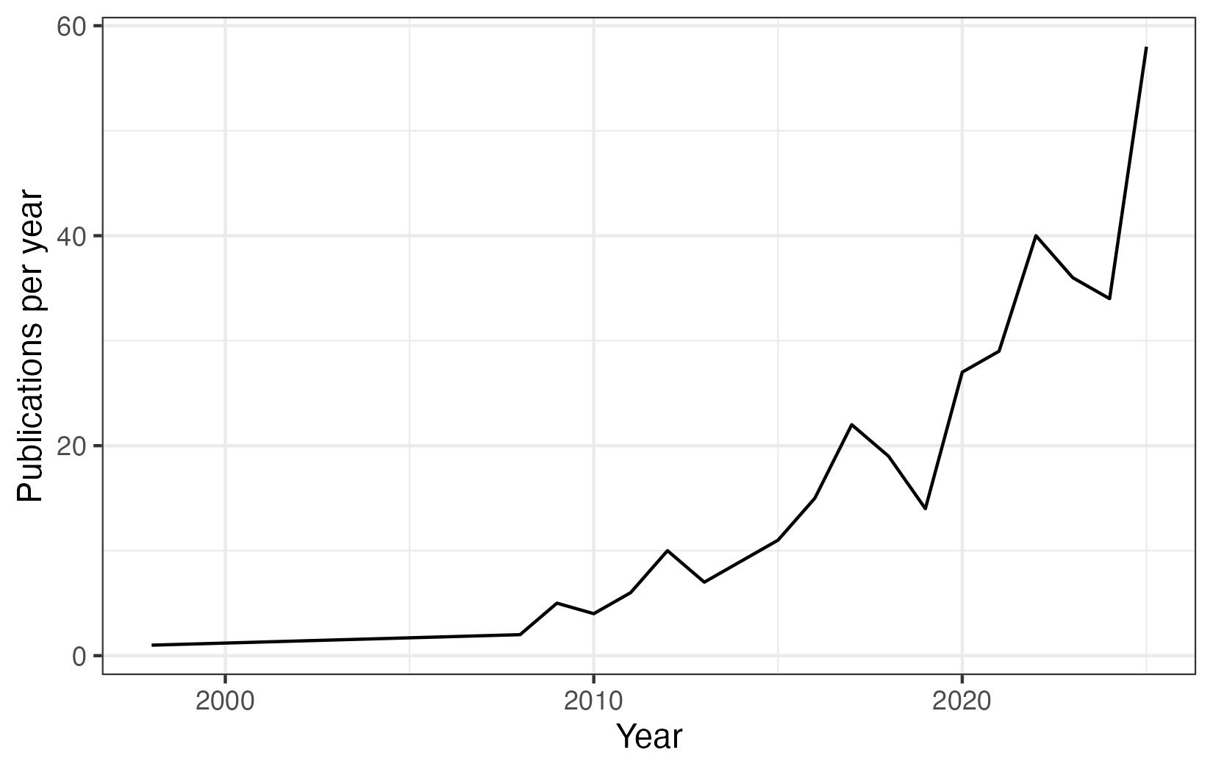
Source: own elaboration, based on information retrieved from Scopus and Web of Science databases.

The exponential growth shown in Figure 1 raises a question that existing scholarship has not fully addressed: how did NCR diffuse across the globe? Foulon and Meibauer (2020) offer the most systematic prior mapping of NCR scholarship, surveying 149 publications by 96 scholars. Their analysis revealed an early expansion into Europe and initial signs of diffusion beyond the Global North. But it was fundamentally prospective: NCR could contribute to Global IR, they argued, if scholars embraced the theory's analytical openness and developed collaborative research designs that bridged the North-South divide. What actually happened – whether, how, and with what consequences NCR spread to the Global South – was left for future work to establish.
That question is particularly pressing because of NCR's distinguishing feature: its analytical flexibility. While theories such as Structural Realism and Neoliberal Institutionalism are often restricted to specific variables (e.g., trade or power distribution), NCR integrates domestic and international variables to understand foreign policy and international outputs. This flexibility has generated productive debates about which variables can be incorporated, how they interact, and what NCR ultimately explains about world politics (Meibauer et al. 2021; Götz 2021). This enables scholars across different regions to adapt NCR to explain their own realities by incorporating variables and concepts. At the same time, the results of this flexibility demand proper evaluation, aiming to understand theory development and adaptation processes. Did NCR actually spread to the Global South? Did Global South scholars adopt NCR as formulated by its canonical architects? Did they adapt it to their own empirical and intellectual contexts? And if adaptation occurred, does it follow any systematic pattern, or is it the accumulated noise of scholars working in isolation from one another?
These are not merely questions about the internal development of a theoretical research program. They bear directly on one of the central debates in contemporary IR: whether the growing participation of non-Western scholars in the discipline represents genuine pluralization of the field's theoretical foundations, or whether it reproduces, in new geographical packaging, the same asymmetric structure in which Southern scholars engage with Northern frameworks without reshaping them. NCR is a revealing case for this debate precisely because its flexible boundaries make it a permissive vehicle for adaptation: if systematic variation in how the theory is used still fails to emerge, the case for genuine Southern agency would be considerably weakened. The Global IR literature has established, with considerable force, that scholars beyond the North Atlantic are agents in knowledge production, not passive recipients (Acharya 2014; Buzan and Acharya 2019; Cerioli 2024). What it lacks is systematic comparative evidence about how that agency operates in practice – through what mechanisms a specific Northern framework is taken up, transformed, and reproduced across diverse Southern scholarly communities over time.
This article provides that evidence. We survey 349 journal articles published in Web of Science- and Scopus-indexed outlets between 1998 and 2025 – more than doubling the empirical basis of prior work (Foulon and Meibauer 2020) – and ask not only who uses NCR and from where, but what they use it for and how. Our analysis proceeds in two steps. First, we map the geographical spread of NCR scholarship using georeferenced data on authors' institutional affiliations and temporal production patterns, establishing when and where the theory's center of gravity shifted. Second, we examine how NCR is deployed across regions, combining a Structural Topic Model that identifies the research agendas scholars pursue under the NCR label with a citation analysis that reveals the theoretical traditions mobilized alongside the approach in different parts of the world.
The results are striking on multiple dimensions. Global South scholars now account for a majority of indexed NCR production, a consolidation of what was, less than a decade ago, only an emerging trend. Scholars outside Europe and North America often deploy NCR predominantly to study their own countries and regions. This adoption, however, has not been a simple replication of the canonical framework. Southern scholars have incorporated systematically different theoretical traditions into their NCR analyses depending on where they work: English School influence is markedly stronger in Latin American scholarship than elsewhere; constructivism is largely absent in South Asian NCR production; decolonial and feminist frameworks register at negligible rates in Middle Eastern and North African work. This happened with low collaboration with Western scholars: co-authorship with Global Northern scholars has remained low (roughly 20 percent of publications) and has not grown proportionally with Southern participation. Southern scholars learned NCR from the canonical texts of the North, adapted it to their own empirical realities and intellectual traditions, and did so with minimal epistemic exchange with the theory's producing core.
We argue that this constellation of findings describes a mode of theoretical engagement the discipline has not yet systematized: what we call autonomous appropriation. Rather than rejecting Northern frameworks or hybridizing them through collaborative exchange, Southern scholars adopt them as legitimating scaffolding for regionally grounded research agendas. At the same time, they selectively incorporated local theoretical traditions in the process, without significant feedback to the core. The result is not a unified global NCR but a set of regionally distinct neoclassical realisms that coexist without convergence. The NCR label travels intact; the theory underneath it does not. This is consistent with the Global IR literature, which has tended to read Southern agency as a driver of disciplinary pluralization without examining whether that pluralization produces genuine epistemic exchange.
This article makes three contributions. First, it provides the most comprehensive empirical mapping of NCR's global diffusion to date, extending prior work in both scale and temporal scope. Second, it advances the methodological toolkit for studying theory diffusion by combining georeferenced bibliometric data, structural topic modeling, and systematic citation analysis. Third, and most substantively, it introduces the concept of autonomous appropriation as an analytical category for understanding how Southern scholars engage with Northern theoretical frameworks: neither through wholesale adoption nor through dialogic hybridization, but through a form of selective, regionally grounded adaptation that proceeds without epistemic integration with the producing core. This concept travels beyond the case of NCR, offering a portable tool for scholars interested in how theoretical knowledge circulates (and fragments) across the discipline's unequal geographical landscape.
Our findings have implications beyond NCR. They suggest that geographic diversification in knowledge production – one of the central ambitions of the Global IR agenda – does not automatically produce the epistemic integration that would make that diversification theoretically consequential. A discipline can become more geographically inclusive while its regional scholarly communities grow further apart in their theoretical reference points and collaborative networks. Recognizing this possibility and understanding the structural conditions that produce it is a necessary step toward a more genuinely Global IR. At the same time, we contribute to the understanding of NCR by moving beyond theoretical reflections, discussing how the theory has been used worldwide. It intends to support current debates about NCR pathways by offering a broader picture of its theoretical possibilities, as well as to inform NCR-users aiming to understand how the theory can inform their analyses.
The article proceeds as follows. The next section reviews NCR's core assumptions and analytical scope, with particular attention to the theoretical flexibility that has shaped its appeal across diverse empirical contexts. The third section presents our empirical design and data. The fourth section maps NCR's geographical spread and documents the shift in North-South production. The fifth section examines regional variation in how NCR is intellectually grounded across the world. A final section draws out implications for debates on NCR's development and the sociology of knowledge production in Global IR.

Neoclassical Realism: core assumptions and analytical scope

Neoclassical realism emerged with the aim of recovering realist perspectives in response to the theoretical tensions that arose in the late 1990s. The end of the Cold War brought the diffusion of approaches that emphasized culture, identities, and domestic variables, and called for reflections on international politics beyond the narrow focus on trade or material power capabilities. At the same time, the collapse of the Soviet Union reinforced existing criticisms that structural realism had failed to anticipate key developments of the late 1980s and struggled to account for the behavior of states that did not conform to its systemic predictions.
It was in this context that a group of scholars began reintegrating domestic politics into realist analysis, retaining the primacy of systemic incentives while insisting that unit-level variables shape how states perceive, process, and respond to structural pressures. The first mention and systematization of the term “neoclassical realism” are attributed to Gideon Rose and his article “Neoclassical Realism and Foreign Policy Theories.” Rose (1998) identifies a common emerging research agenda among authors such as Christensen (1996), who demonstrated that external threats only translate into coherent foreign strategy when political leaders are capable of mobilizing domestic support; Zakaria (1999), who argued that a state’s external behavior relates to its ability to extract and mobilize resources from society; and Schweller (1996), who poses a challenge to the neorealist axiom of universal balancing behavior by introducing unit-level variables, showing that elite preferences, revisionist state goals, and the nature of domestic coalitions help explain a wider range of strategies, including underbalancing or bandwagoning. Rose's key contribution was not to originate these arguments but to name the research program they collectively constituted and to clarify its theoretical logic: systemic incentives shape foreign policy outcomes, but they do so through intervening variables at the unit level.
These foundational studies reintroduced domestic politics into realist analysis and established a framework that models how systemic incentives are transmitted into states’ foreign policy behavior through unit-level intervening variables, creating a bridge between structural and classical realism. Not by chance, as Taliaferro (2006, pp. 464–495) emphasizes, the approach draws not only on Waltzian parsimony but also on the analytical tradition of classical realists such as Morgenthau, Kissinger, and Wolfers, who foregrounded decision-makers, domestic constraints, and the gap between systemic incentives and foreign policy outputs. NCR inherits from structural realism the causal primacy of the international environment and from classical realism the insistence that this environment is refracted through domestic political processes before it shapes state behavior (Rathbun 2008).
Efforts to systematize this research program culminated in the contributions of Lobell, Ripsman, and Taliaferro (2009, 2016). Ripsman et al. (2016) propose a unified analytical framework organized around two pillars: (i) a foundational commitment to a realist theory of systemic incentives – whether offensive, defensive, or otherwise specified – and (ii) four clusters of intervening variables: leader images, strategic culture, state-society relations, and domestic institutions. This typology sought to impose theoretical discipline on a proliferating field in which scholars had mobilized a wide and heterogeneous array of domestic-level factors. The framework also clarified NCR's scope: systemic incentives provide states with "considerable latitude" in articulating their interests and merely "set parameters" for behavior (Lobell et al. 2009: 7), leaving substantial room for unit-level variation in foreign policy outputs.
Even as Neoclassical Realism consolidated as a recognized research program, empirical scholarship continued expanding its repertoire of intervening variables well beyond the four canonical clusters. Examples include: extraction and mobilization capacity (Christensen, 1996; Zakaria, 1998; Taliaferro, 2006), public opinion (Brawley, 2009), regime type (Juneau, 2015), national institutions (Friedberg, 2000; Taliaferro, 2009; Ripsman, 2002), national identity (Sterling-Folker, 2009; Hadfield-Amkhan, 2010), nationalism (Lai, 2013; Schweller, 2018; Oliveira, 2021), strategic culture (Dueck, 2004; Oliveira, 2021), government vulnerability (Schweller 2006; Dawood; Oliveira, 2025 forthcoming), ideas (Kitchen, 2010; Meibauer, 2020) and elite beliefs (He, 2017), among others. This proliferation reflects the theory's internal logic: if systemic incentives are mediated by domestic structures, and if domestic structures vary across states and contexts, then the set of potentially relevant intervening mechanisms is in principle open-ended.
This openness has been NCR's most persistent source of both analytical appeal and theoretical controversy. Critics argue that the framework lacks consistency, employs intervening variables in an ad hoc manner, and risks degenerating into a "laundry list" that can accommodate any outcome post hoc (Legro and Moravcsik 1999; Narizny 2017; Wivel 2005). For these critics, NCR's explanatory gains come at an unacceptable cost to theoretical parsimony and falsifiability. Proponents, however, resist this characterization. Lobell, Ripsman, and Taliaferro (2009: 10) themselves acknowledge that "there is no single neoclassical realist theory, but rather a diversity of neoclassical realist theories" – a heterogeneity they regard not as a sign of theoretical decay but as a practical response to empirical variation. More recently, Meibauer et al. (2021) and Götz (2021) have revisited NCR's paradigmatic boundaries with greater analytical precision, distinguishing between legitimate theoretical extension and problematic eclecticism.
In line with NCR's proponents, we argue that the framework's flexibility is analytically productive precisely because it enables adaptation to diverse empirical contexts. While parsimony is a genuine theoretical virtue, rigidity carries a cost: scholars confronting empirical settings that do not conform to a theory's original scope face a difficult choice between abandoning the framework or engaging in conceptual stretching. Sometimes, the result is a misapplication of concepts, variables, and categories to fit realities for which they were not designed (Sartori 1970; Collier and Mahon 1993).
NCR's flexibility mitigates this trade-off by allowing scholars to incorporate variables (and concepts) relevant to their own contexts while retaining the broader explanatory architecture provided by realist systemic logic. As Foulon and Meibauer (2020) put it, "unit-level variables differentiate states, historicize and contextualize behavior, and lend agency to decision-makers." Different domestic structures, regional contexts, and historical conjunctures may legitimately foreground different intervening mechanisms without departing from a realist foundation centered on relative power and external incentives. This contextual flexibility distinguishes NCR from more parsimonious structural theories and is precisely what may enable the framework to travel across empirical settings that structural realism treats as anomalous or underdetermined.

NCR's Flexibility and Global South Resonance

NCR's flexibility may offer special incentives for scholars working in the Global South, understood here as the heterogeneous group of developing and middle-income states that occupy peripheral or semi-peripheral positions in the international political and economic system (IMF 2024), to adopt and adapt the framework. NCR's realist foundations, i.e., systemic pressures, relative power, and the constraints imposed by an anarchical environment, resonate with intellectual traditions that scholars in Latin America, the Middle East, and Asia developed largely independently from the neoclassical realist label. The concept of peripheral realism (Escudé 1992; Schenoni and Escudé 2016), Ayoob's (1983, 2002) subaltern realism, Jaguaribe's (1980) framework of peripheral autonomy, and Puig's (1980) doctrine of Latin American autonomy all share with NCR a central preoccupation: how do states operating under material constraints and facing stronger external actors navigate the tension between systemic pressures and domestic political imperatives? In the Middle Eastern context, Korany (1987) and Sayigh (1991) similarly foregrounded the interaction between external vulnerability and domestic fragility as the defining condition of Third World foreign policy, mapping directly onto NCR's transmission belt logic. In Asia, Johnston's (1995) work on strategic culture in Chinese grand strategy offered an early demonstration that domestically embedded variables shape how systemic incentives are interpreted and acted upon, anticipating central NCR arguments before the label existed.
These traditions emerged from the empirical realities of peripheral statehood, and their convergence with NCR's analytical logic creates a prior theoretical resonance that may have facilitated the theory's uptake beyond the North Atlantic. Indeed, NCR's intervening variables, e.g., state-society relations, resource extraction capacity, elite vulnerability, and strategic culture, map naturally onto the concerns that Global South scholarship had long identified as central to understanding foreign policy in peripheral settings (Carvalho and Mares 2025; Tickner 2003; Russell and Tokatlian 2003).
NCR's potential to spread across the Global South was perceived early. Foulon and Meibauer (2020), while surveying 149 NCR publications by 96 scholars, noted an increasing trend of Global Southern production. Subsequent scholarship confirmed the pattern: NCR has been applied to cases as varied as Brazil (Baracuhy 2006; de Oliveira and Dawood 2024), China (Lai 2013; Lim and Gill 2025), Vietnam (Gill 2023), Indonesia (Sari 2019), the Philippines (Magcamit 2019), and Turkey (Alagoz 2021), among many others. These works offer important reflections on how the theory, though originating in the Global North, has traveled and been adapted across diverse empirical and regional contexts.
Recent scholarship has begun to take this convergence seriously. Cerioli (2024) argues that fully realizing NCR's analytical potential requires engaging with how it is adapted, contested, and transformed outside its original North Atlantic centers of production. As she notes, "traditions are negotiated across time and space, mutating according to the intellectual demands of a scholarly community" (Cerioli 2024: 5) – a process of negotiation that is not merely degenerative but can produce theoretical enrichment when the empirical demands of peripheral contexts introduce new analytical problems that existing NCR variables do not adequately capture. This points toward an important possibility: that Global South scholars may not simply have applied NCR to new cases but may have reshaped it in the process, selectively incorporating regional theoretical traditions and locally resonant intervening variables in ways that produce variants of the framework distinct from the canonical North American formulation.

NCR meets Global IR: Global Southern agency in theory production and adaptation

This possibility connects directly to a broader debate within IR about the role of Global South scholars in the production of theoretical knowledge. A central argument of the Global IR literature is that scholars beyond the North Atlantic are not merely consumers of theory developed elsewhere but active agents in the production and transformation of disciplinary knowledge (Acharya 2014; Buzan and Acharya 2019). This claim has been developed along several lines. Tickner and Wæver (2009) document how different regions produce distinct "geocultural epistemologies" — ways of knowing international relations that reflect the historical experiences, institutional structures, and intellectual traditions of particular scholarly communities rather than universal disciplinary standards. Tickner (2003) shows more specifically that Latin American IR scholars have long engaged with mainstream frameworks not as passive recipients but as critical interlocutors, selectively appropriating, contesting, and reformulating Northern theories in light of Southern empirical realities. Alejandro (2019), examining the internationalization of IR in Brazil and India, demonstrates that this process of selective engagement produces nationally and regionally inflected variants of mainstream approaches that diverge systematically from their original formulations. More broadly, Wæver (1998) and Kristensen (2018) have shown that the sociology of the discipline – its citation networks, institutional hierarchies, and publishing structures – shapes what counts as theoretical knowledge and whose contributions gain visibility, creating conditions under which Southern adaptation may occur without ever registering as such in the mainstream literature.
Taken together, this literature establishes that Southern agency in knowledge production is real but structurally constrained: scholars engage with Northern frameworks actively, but do so within a disciplinary architecture that tends to render their adaptations invisible or peripheral. What remains underspecified is the concrete form that this agency takes — through what mechanisms specific Northern frameworks are taken up, transformed, and reproduced across diverse Southern communities. NCR, with its permissive theoretical boundaries and its resonance with pre-existing Southern intellectual traditions, offers a uniquely tractable case for investigating these mechanisms empirically. Whether Global South scholars have exercised the latitude that NCR's flexibility affords them — and in what form, to what degree, and with what consequences for the coherence of the research program — is precisely what the analysis that follows sets out to determine.

Empirical Design

This article investigates NCR's global diffusion through a two-step research design that moves from the geography of knowledge production to the intellectual content of regional scholarship. The first step maps who produces NCR scholarship and from where; the second characterizes how the framework is deployed across regions. Together, these steps allow us to move beyond counting users of a theory to examining what they do with it – a methodological choice that reflects the article's core analytical ambition. In this section, we describe data collection procedures and the analytical steps deployed in our analysis.

Data

We surveyed the scholarly production about this theory. We used the query “neoclassical realism” to search for academic publications in the two main platforms for research tools – Web of Science (WoS) and Scopus. Our WoS search returned 343 results, while we found 422 results in Scopus. We then merged both datasets and removed duplicate observations based on titles, journals, and Digital Object Identifiers (DOI). Finally, we retained only journal articles for the analysis, excluding books, book chapters, and working papers, for three reasons: (1) data for these observations tend to provide more complete metadata, presenting full information about authors, affiliations, abstracts, and citations, which are all key for our analysis; (2) they consist of validated peer-reviewed production, which is also (3) open to unsolicited submissions, making them more accessible for a broader range of scholars across institutional contexts, thus reducing selection bias toward established or invited contributors.
Our final sample includes 349 journal articles published between 1998 and 2025. These articles mention "neoclassical realism" at any point, whether employing NCR as their primary analytical framework, engaging with it critically, or situating their work in relation to it. This inclusive criterion reflects our research design: we are interested in the sociology of NCR scholarship as a whole, including the intellectual ecosystem that surrounds its use, rather than in a narrow sample of articles that self-identify as NCR applications.

Methods: Step 1

Having assembled a dataset of all indexed publications mentioning NCR from 1998 to 2025, we begin by mapping the spread of NCR across the world and identifying where it has gained leverage since Rose (1998). Establishing the geographical scope and temporal trajectory of NCR diffusion is a necessary precondition for the analysis of adaptation: regions with substantial NCR production are those where we can meaningfully examine whether the framework has been modified, and how.
We therefore combine statistical analysis with georeferenced information about which countries have been producing NCR scholarship, using authors' institutional affiliations as recorded at the time of publication. For articles with authors affiliated with institutions in different countries or regions, we assign one entry to each distinct regional affiliation — meaning a co-authored article involving scholars from the Global North and Global South is counted once in each group. This decision reflects our interest in the presence and volume of scholarly engagement across regions rather than in the net directionality of any single publication. We classify countries into Global North and Global South following the International Monetary Fund's Advanced Economies classification, which we adopt as our operationalization of core and peripheral positions in the global political economy.

Methods: Step 2

After mapping NCR's spread across the world, the second step examines the intellectual structure of NCR scholarship across regions. We focus on two dimensions: the substantive research agendas that scholars pursue under the NCR label, and the theoretical traditions they mobilize alongside the framework. We assume that theoretical adaptation would only make sense if scholars are studying their own regions, so that they end up needing to include concepts and variables related to their contexts.
For the first dimension, we rely on a Structural Topic Model (STM) estimated on the abstracts of all 349 articles. STM is an unsupervised machine-learning method that identifies latent topics in a text corpus by modeling the co-occurrence of words across documents, while allowing topic prevalence to vary as a function of document-level covariates (Roberts et al. 2014; Grimmer et al. 2022). This makes STM particularly well suited to our analytical purpose: unlike standard topic models, it can estimate whether the distribution of topics varies systematically across regions, which is precisely the quantity of interest for our argument about regional adaptation.
Although the corpus contains articles published in multiple languages, all indexed journals require authors to provide titles and abstracts in English. This is why our textual analysis relies on English-language abstracts across the full sample, ensuring comparability without restricting the geographic scope of the corpus.
Before estimation, we applied a standard pre-processing pipeline: tokenization, lowercasing, punctuation removal, stopword removal, stemming, and elimination of terms appearing in fewer than 35 or more than 104 documents. We selected the number of topics by maximizing semantic coherence and exclusivity scores across a range of candidate models (Mimno et al. 2011; Roberts et al. 2014), settling on a final solution of K = 12 topics. All pre-processing decisions and model diagnostics are reported in the Supplementary Materials. Topics were interpreted and labeled by the authors through close reading of the highest-probability terms and the most representative documents for each topic, followed by a joint discussion process to resolve disagreements.
For the second dimension, we deploy two complementary analytical tools. First, we conduct an automated citation analysis designed to reveal the theoretical traditions that NCR scholars mobilize across regions. We constructed a list of representative authors for each of the major theoretical schools present in IR (Structural Realism, Classical Realism, Liberalism, Constructivism, the English School, and Decolonial and Feminist approaches) and searched reference lists for citations to any work by these authors. The complete list of authors used to represent each school is available in the Appendix. We then calculated, for each region, the proportion of articles citing at least one author from each theoretical school, producing the regional citation profiles
We complement this proportional analysis with co-citation network analysis for each region. While the citation proportions reveal how frequently each theoretical tradition appears alongside NCR in different regional contexts, network analysis allows us to identify which specific authors and works are structurally central to the intellectual infrastructure of each regional community, which means the references that consistently appear together, functioning as shared anchors of regional NCR scholarship. For each region, we constructed a co-citation network in which nodes represent cited authors and edges represent the frequency with which two authors are cited together within the same article. We then calculated standard network centrality measures, i.e., degree and betweenness centrality, to identify the authors who occupy the most influential positions in each regional network: those cited most broadly across the regional corpus, and those who serve as bridges between otherwise distinct theoretical clusters.
Together, the STM and the citation analyses provide a multi-layered characterization of how NCR is intellectually grounded across the discipline's geographical landscape. This approach captures the intellectual choices scholars actually make rather than relying on self-descriptions of theoretical commitments, which may be incomplete or strategic.

The NCR spread around the world

Despite being created in the US, the theory has spread around the world since Rose (1998) labelled it “Neoclassical Realism.” Figure 2 below displays the number of NCR articles published by country – the darker the country, the more articles scholars based on its territory have published. It shows that while US-based scholars continue to lead NCR production, European researchers, especially those based in Germany and the United Kingdom, have also embraced the theory. The European continent has actually become the leading source of NCR articles, reaching 152 publications, compared to 53 articles published by US-based scholars. This actually follows broader trends in the field, as Global Northern scholars tend to have more access to indexed publications (Kristensen 2018; Lohaus and Wemheuer-Vogelaar 2020)
At the same time, despite the difficulties in accessing indexed publications, Global Southern countries also presented a significant incorporation of NCR. This incorporation, however, was somehow unequal. Sub-Saharan African states are relatively absent from NCR dynamics, having published only two articles. Such incorporation was more advanced in South Asia (9 articles) and Latin America (28 articles), suggesting the theory's applicability in alternative regional contexts. Still, two regions emerged as key sides for Neoclassical Realism: the Middle East and North Africa (48 articles) and Asia-Pacific (80 articles). While Turkey leads NCR production in the former (33 articles), China (28) is the powerhouse of such scholarship in Asia, followed by two countries acknowledged as Global Northern: Australia (12) and Japan (10).
Figure 2 – Geographical distribution of NCR publications
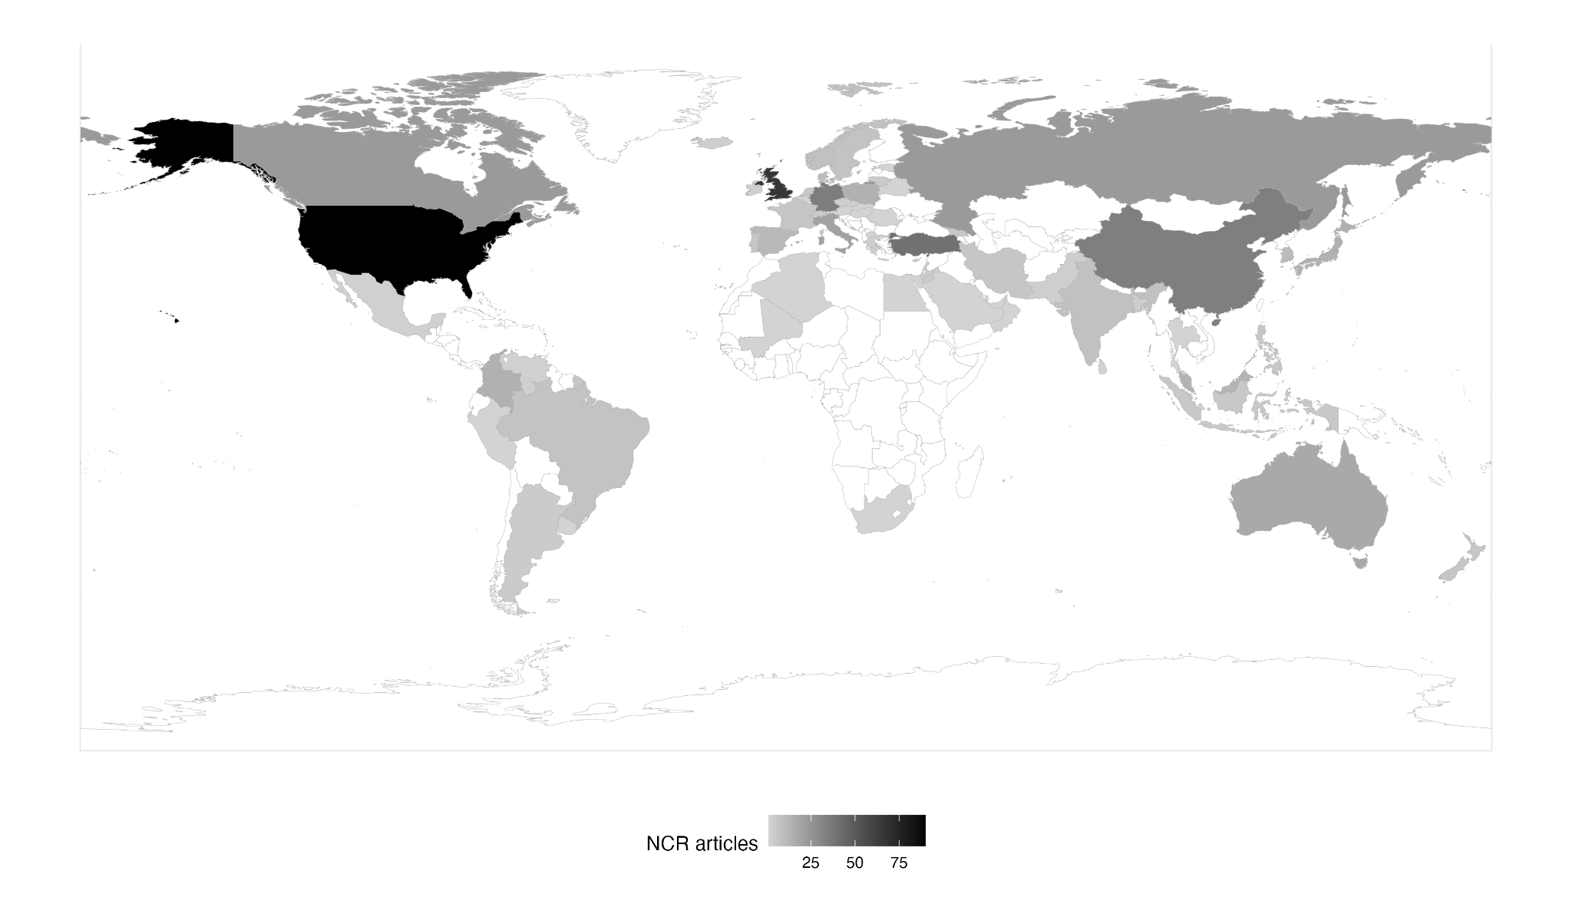
These numbers are based on indexed publications, which is not the case for most journals in Global Southern regions. However, they have been boosted by the increasing indexation of these journals, as well as area studies publications. Most Latin American articles were published in Latin American journals, such as Foro Internacional (3), Colombia Internacional, Estudos Internacionais, and Revista Brasileira de Política Internacionais (2 articles in each journal). In the Middle East, Turkish journals – All Azimuth (6) and Uluslararasi Iliskiler (4) – and area studies publications – Contemporary Review of the Middle East (3) and Southeast European and Black Sea Studies (3) – accounted for most articles. A similar outcome happened in Asia-Pacific: the Journal of Asian Security and International Affairs, Millennial Asia (3 articles each), Pacific Focus, Korean Journal of Defense Analysis, Akademika, and the Asian Journal of Middle Eastern and Islamic Studies (2 articles each) were the key outlets for regional NCR publications. On the other hand, the lack of indexed journals may also help explain the low number of Sub-Saharan African publications.
The NCR advance in the Global South was such that there are currently more publications by Global Southern scholars than those in the Global North. Figure 3 below illustrates these dynamics, tracking yearly NCR production by Global Southern and Northern scholars. We coded as Global Northern those countries classified as Advanced Economies according to the International Monetary Fund. The figure reveals a clear trajectory: Global Northern scholars dominated NCR production through the 2000s. Then, during the 2010s, Southern production grew steadily and consistently, closing the gap with the North. By the end of the period under analysis, Global Southern scholars account for a majority of indexed NCR publications — a consolidation of what Foulon and Meibauer (2020) had detected only as an incipient trend.

Figure 3 – Global South x North Productivity
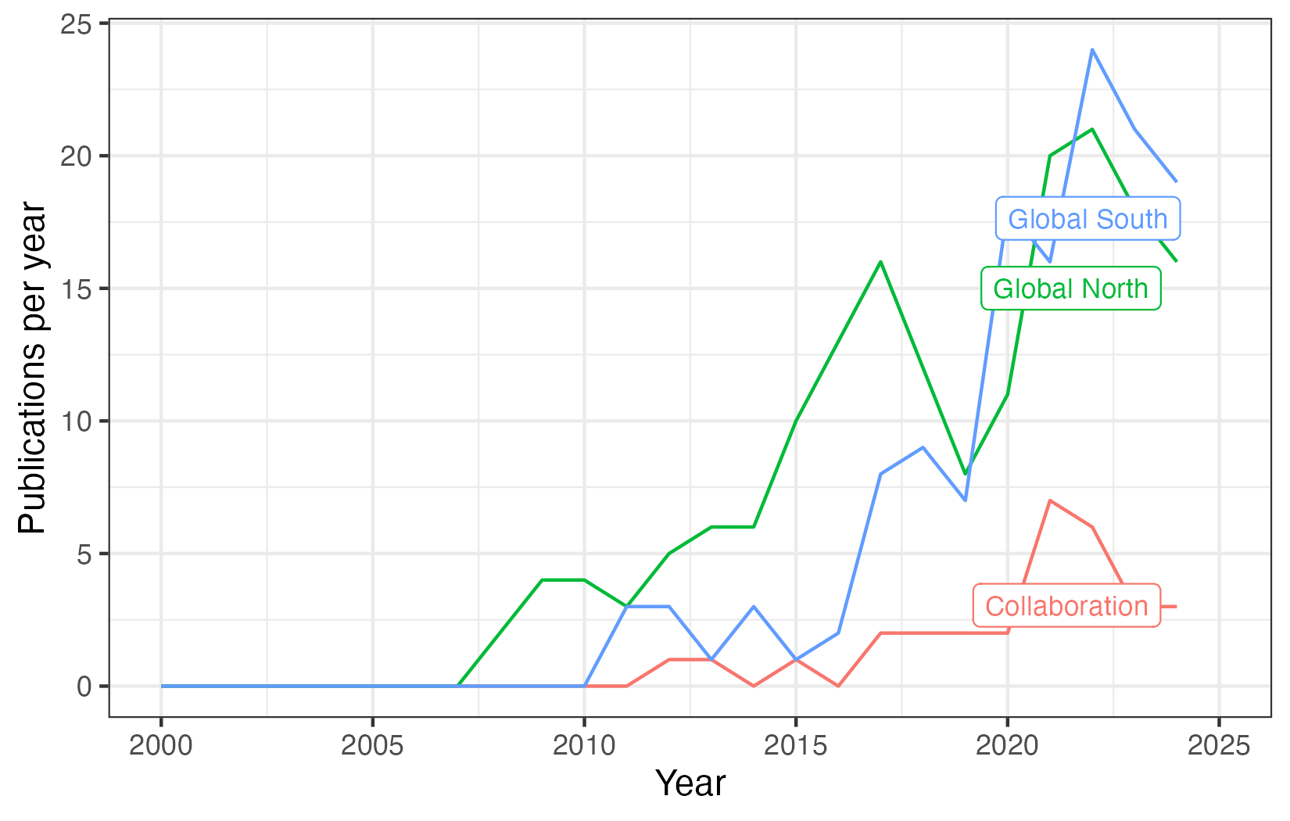

Still, despite NCR's potential to bridge knowledge production between core and peripheral scholarships due to its flexibility (Cerioli 2025), it has not yet shaped high levels of collaboration between Global Southern and Northern scholars. Figure 3 also shows that, despite increasing Global Southern participation in NCR knowledge production, collaboration between core and peripheral scholars remains relatively low, reaching around 20% of yearly publications.
This pattern carries a specific inferential implication: if Southern scholars were producing NCR in close dialogue with Northern counterparts, we would expect co-authorship rates to rise as Southern participation expanded. The stability of that rate instead suggests that Southern scholars have largely learned NCR through canonical Northern texts and subsequently applied and adapted the framework to their own empirical realities with limited feedback to the producing core. This suggests, as we argue in the introduction, is a process of autonomous appropriation, i.e., Global Southern scholars adopt NCR but are not included by the epistemic community leading its production. As a result, they adapt the framework to their own analytical needs, including the variables that they consider key to explain the reality of their countries and regions.
Still, while this evidence is suggestive of autonomous appropriation, whether this process has produced genuine theoretical adaptation (i.e., distinct regional variants of NCR with different intellectual foundations) or mere replication under a common label is a question that the distribution of publications cannot answer on its own. It is precisely to that question that the next section turns.

The intellectual bases of NCR across regions

The first step to understand Neoclassical Realism's application in different regions is to investigate what scholars use NCR for. Existing scholarship argues that IR scholarship outside the Global North tends to be parochial, focused on studying their own countries and regions (Biersteker 2009; Alejandro 2019; Carvalho et al. 2024). Therefore, it is reasonable to expect that scholars outside Europe and the US are focused on topics related to their regions, while American and European researchers may focus on other issues. However, it is still necessary to understand whether this actually applies.
In order to investigate it, we divide all countries into seven regions, as defined by the World Bank Development Indicators (WDI). The only exception was Turkey, which was coded as being part of “Europe & Central Asia” but, considering that most of its population does not live in the European part of the country – and, therefore, its academic dynamics may not be as European as those of other countries – we coded it as part of “Middle East & North Africa.” Then, we rely on a text analysis of the abstracts of all documents in our dataset by relying on a Structural Topic Model. We relied on a standard pre-processing procedure, by stemming words, removing punctuation and stopwords, transforming all characters to lowercase, and removing rare and common terms. Then, we selected the number of topics for the model, aiming to maximize exclusivity and semantic coherence (Mimno et al. 2011; Roberts et al. 2014; Grimmer et al. 2022) – the resulting model contains X topics. All procedures are detailed in the Supplementary procedure.

Most cited
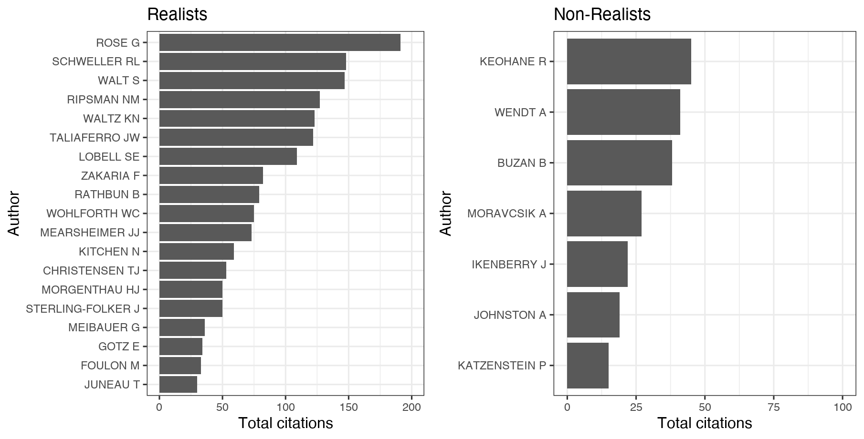

PROPORÇÃO DE PAPERS QUE CITAM AUTORES DE ESCOLAS TEÓRICAS (MOSTRA AS DIFERENTES FORMAS DE SE USAR A NCR ENTRE REGIÕES)
Region | Constructivism | Structural Realism | Classical Realism | Liberalism | English School | Decol. and Feminism | NCR
East Asia & Pacific | 0.092 | 0.322 | 0.069 | 0.230 | 0.103 | 0.057 | 0.667
Europe & Central Asia | 0.214 | 0.433 | 0.214 | 0.344 | 0.228 | 0.074 | 0.744
Latin America & Caribbean | 0.214 | 0.393 | 0.214 | 0.250 | 0.357 | 0.143 | 0.679
Middle East & North Africa | 0.059 | 0.294 | 0.176 | 0.235 | 0.118 | 0.000 | 0.647
North America | 0.231 | 0.508 | 0.215 | 0.369 | 0.200 | 0.092 | 0.785
South Asia | 0.000 | 0.333 | 0.000 | 0.000 | 0.222 | 0.111 | 0.667

Most Approached Topics

Figure X – Co-citation Network (Latin America)
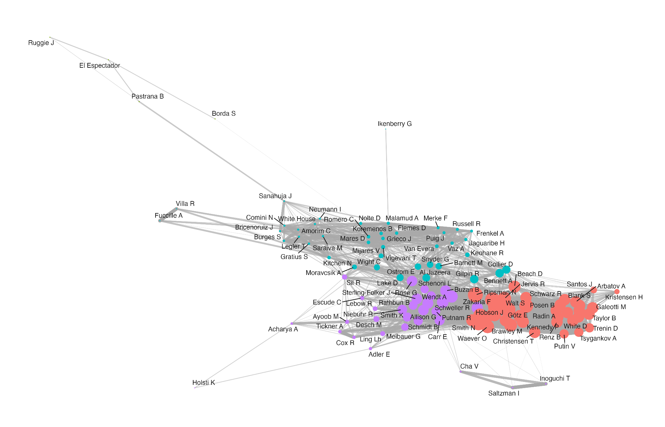
Figure X – Co-citation Network (Asia-Pacific)
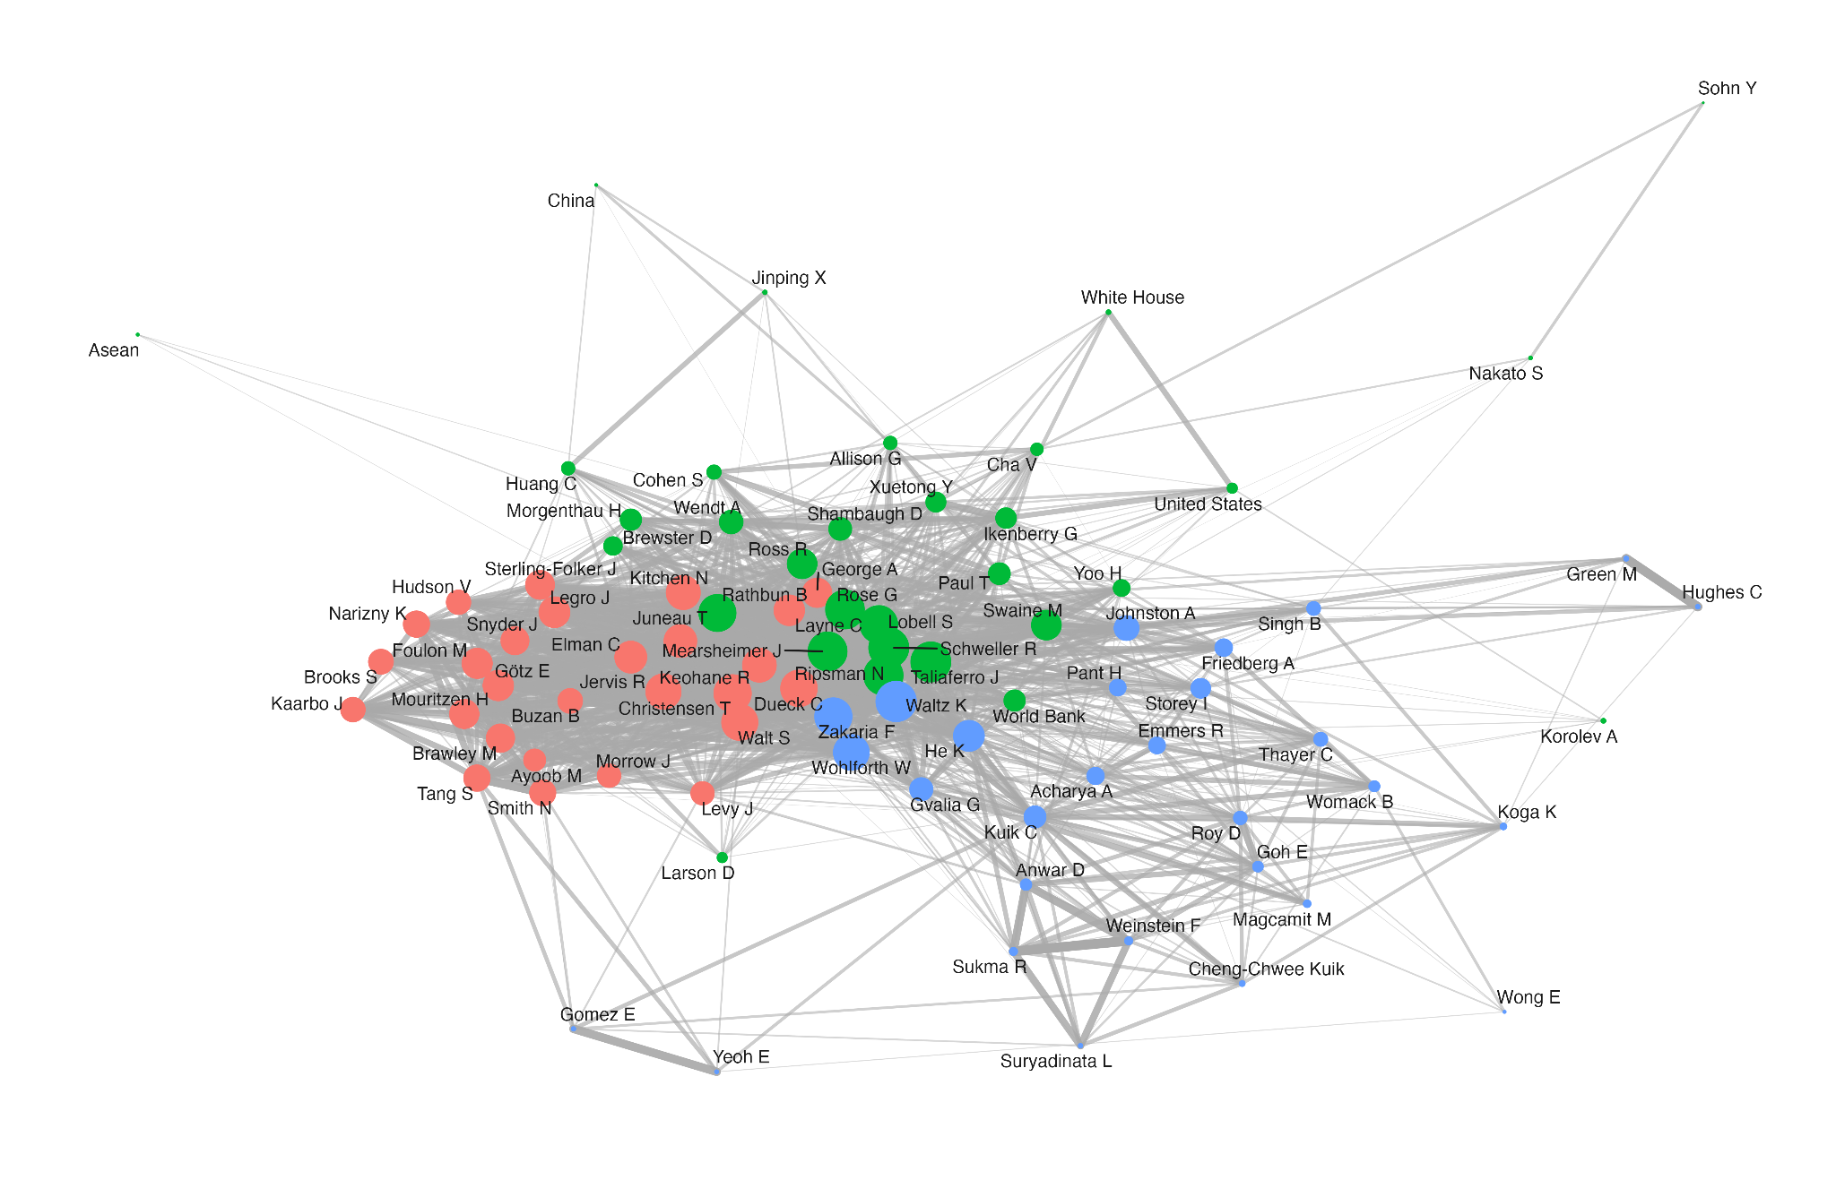
Figure X – Co-citation Network (Middle East and North Africa)
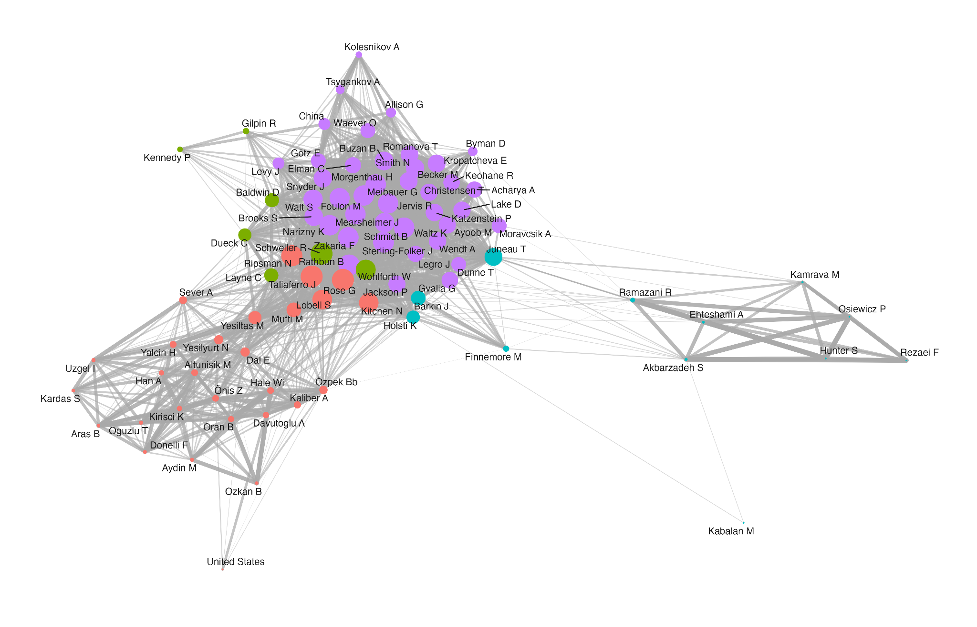

Conclusion

References

Acharya A (2014) Global international relations (IR) and regional worlds. International Studies Quarterly 58(4): 647–659.
Acharya, Amitav. 2014. ‘Global International Relations (IR) and Regional Worlds: A New Agenda for International Studies’. International Studies Quarterly 58 (4): 647–59.
Alagoz E (2021) Turkey’s own “pivot to Asia”: A neoclassical realist analysis. Asia Europe Journal 19: 291–307.
Alejandro, Audrey. 2019. Western Dominance in International Relations? The Internationalisation of IR in Brazil and India. London: Routledge.
Ayoob, Mohammed. 1983. ‘Security in the Third World: The Worm about to Turn?’ International Affairs 60 (1): 41–51.
Baracuhy B (2006) A crise da Liga das Nações de 1926: realismo neoclássico, multilateralismo e a natureza da política externa brasileira. Contexto Internacional 28(2): 355–397.
Biersteker, Thomas. 2009. ‘The Parochialism of Hegemony: Challenges for “American” International Relations’. In International Relations Scholarship around the World, edited by Arlene B. Tickner and Ole Wæver. Worlding beyond the West. Routledge.
Brawley MR (2009) Analytical liberalism versus neo-classical realism: domestic politics and British foreign policy, 1900–1914. Available at: http://papers.ssrn.com/abstract=1451538 (accessed 10 February 2026).
Buzan B and Acharya A (2019) The Making of Global International Relations: Origins and Evolution of IR at Its Centenary. Cambridge: Cambridge University Press.
Carvalho, Thales, and David Mares. 2025. ‘International Security Governance in Latin America: A Historical Assessment’. In Oxford Research Encyclopedia of International Studies. Oxford University Press.
Carvalho, Thales, Vinicius Santos, and Yulieth Martínez. 2024. ‘Following the Trail of Words: Mapping the Trending Topics of Graduate Research in the Brazilian IR Scholarship (1987-2018)’. Brazilian Political Science Review 18 (1): e0003.
Cerioli, Luíza. 2024. ‘Neoclassical Realism, Global International Relations, and the Unheard Echoes of Realist Practices from the South’. The British Journal of Politics and International Relations 27 (1): 369–86.
Christensen, Thomas J. 1996. Useful Adversaries: Grand Strategy, Domestic Mobilization, and Sino-American Conflict, 1947-1958. Princeton Studies in International History and Politics. Princeton University Press.
Collier, David, and James E. Mahon. 1993. "Conceptual 'Stretching' Revisited: Adapting Categories in Comparative Analysis." American Political Science Review 87(4): 845–855.
Dawood & Oliveira (2025, forthcoming)
de Oliveira A and Dawood L (2024) Reflexões sobre a liderança na política de defesa do Brasil para o Atlântico Sul. Carta Internacional 23: 273–310.
Dueck C (2004) Ideas and alternatives in American grand strategy, 2000–2004. Review of International Studies 30(4): 511–535.
Escudé, Carlos. 1992. Realismo Periférico: Fundamentos Para La Nueva Política Exterior Argentina. Política y Sociedad. Planeta.
Foulon M and Meibauer G (2020) Realist avenues to global International Relations. European Journal of International Relations 26(4): 1203–1229.
Friedberg AL (2000) In the Shadow of the Garrison State: America’s Anti-Statism and Its Cold War Grand Strategy. Princeton, NJ: Princeton University Press, pp. 245–295.
Gill D (2023) Locating the evolving Vietnam–India security partnership in Hanoi’s hedging strategy with major powers: A neoclassical realist analysis. Millennial Asia 0(0). DOI: 10.1177/09763996231178125.
Götz, Elias. 2021. ‘Neoclassical Realist Theories, Intervening Variables, and Paradigmatic Boundaries’. Foreign Policy Analysis 17 (2): oraa026.
Grimmer, Justin, Margaret E. Roberts, and Brandon M. Stewart. 2022. Text as Data: A New Framework for Machine Learning and the Social Sciences. Princeton University Press.
Hadfield-Amkhan A (2010) British Foreign Policy, National Identity, and Neoclassical Realism. Lanham: Rowman & Littlefield.
He K (2017) Explaining United States–China relations: Neoclassical realism and the nexus of threat–interest perceptions. The Pacific Review 30(2): 133–151.
Jaguaribe H (1980) Autonomia periférica e hegemonia cêntrica. Relações Internacionais 3: 91–130.
Johnston, Alastair Iain. 1995. Cultural Realism: Strategic Culture and Grand Strategy in Chinese History. Princeton: Princeton University Press.
Juneau T (2015) Squandered Opportunity: Neoclassical Realism and Iranian Foreign Policy. Stanford: Stanford University Press.
Kitchen N (2010) Systemic pressures and domestic ideas: A neoclassical realist model of grand strategy formation. Review of International Studies 36(1): 117–143.
Korany, Bahgat. 1987. "Foreign Policy in the Third World: An Introduction." International Political Science Review 8(1): 7–20.
Kristensen, Peter Marcus. 2018. ‘International Relations at the End: A Sociological Autopsy’. International Studies Quarterly, ahead of print, May 3.
Lai YM (2013) Nationalism and Power Politics in Japan's Relations with China: A Neoclassical Realist Interpretation. 1st ed. London: Routledge. DOI: 10.4324/9780203100103.
Legro JW and Moravcsik A (1999) Is anybody still a realist? International Security 24(2): 5–55.
Lim Y and Gill B (2025) Neoclassical realism, nationalism and the evolution of China’s revisionism in maritime East Asia. Journal of Asian Security and International Affairs 12(4): 433–459.
Lobell S, Taliaferro J and Ripsman N (eds) (2009) Neoclassical Realism, the State, and Foreign Policy. New York: Cambridge University Press.
Lobell, Steven E., Norrin M. Ripsman, and Jeffrey W. Taliaferro, eds. 2009. Neoclassical Realism, the State, and Foreign Policy. 1st edn. Cambridge University Press.
Lohaus, Mathis, and Wiebke Wemheuer-Vogelaar. 2020. ‘Who Publishes Where? Exploring the Geographic Diversity of Global IR Journals’. International Studies Review, August 29, viaa062.
Magcamit M (2019) The Duterte method: A neoclassical realist guide to understanding a small power’s foreign policy and strategic behaviour in the Asia-Pacific. Asian Journal of Comparative Politics 5(4): 416–436.
Meibauer G (2020) Interests, ideas, and the study of state behaviour in neoclassical realism. Review of International Studies 46(1): 20–36.
Meibauer, Gustav, Linde Desmaele, Tudor Onea, et al. 2021. ‘Forum: Rethinking Neoclassical Realism at Theory’s End’. International Studies Review 23 (1): 268–95.
Mimno, David, Hanna Wallach, Edmund Talley, Miriam Leenders, and Andrew McCallum. 2011. ‘Optimizing Semantic Coherence in Topic Models’. Proceedings of the Conference on Empirical Methods in Natural Language Processing, 262–72.
Narizny K (2017) On systemic paradigms and domestic politics: A critique of the newest realism. International Security 42(2): 155–190.
Oliveira ACG de (2021) From panda to dragon: An analysis of China’s maritime actions and reactions in the East China Sea and their implications since 2012. Contexto Internacional 43(1): 147–171.
Puig, Juan Carlos. 1980. Doctrinas internacionales y autonomía latinoamericana. Caracas: IILDIS.
Rathbun, Brian C. 2008. "A Rose by Any Other Name: Neoclassical Realism as the Logical and Necessary Extension of Structural Realism." Security Studies 17(2): 294–321.
Ripsman N, Taliaferro J and Lobell S (2016) Neoclassical Realist Theory of International Politics. New York: Oxford University Press.
Ripsman NM (2002) Peacemaking by Democracies: The Effect of State Autonomy on the Post-World War Settlements. University Park: Penn State University Press.
Ripsman, Norrin M., Jeffrey W. Taliaferro, and Steven E. Lobell. 2016. Neoclassical Realist Theory of International Politics. Oxford University Press.
Roberts, Margaret E., Brandon M. Stewart, Dustin Tingley, et al. 2014. ‘Structural Topic Models for Open-Ended Survey Responses: STRUCTURAL TOPIC MODELS FOR SURVEY RESPONSES’. American Journal of Political Science 58 (4): 1064–82.
Rose, Gideon. 1998. ‘Neoclassical Realism and Theories of Foreign Policy’. World Politics 51 (1): 144–72.
Russell, Roberto, and Juan Gabriel Tokatlian. 2003. "From Antagonistic Autonomy to Relational Autonomy: A Theoretical Reflection from the Southern Cone." Latin American Politics and Society 45(1): 1–24.
Sari A (2018) A neoclassical realist explanation of Indonesia’s involvement in Muslim-related secessions in non-Muslim countries. Asian Journal of Comparative Politics 4(3): 213–241.
Sartori, Giovanni. 1970. "Concept Misformation in Comparative Politics." American Political Science Review 64(4): 1033–1053.
Sayigh, Yezid. 1991. "Confronting the 1990s: Security in the Developing Countries." Adelphi Papers 31(251). London: IISS.
Schenoni, Luis, and Carlos Escudé. 2016. ‘Peripheral Realism Revisited’. Revista Brasileira de Política Internacional 59 (1).
Schmidt BC (2014) A realist view of the Eurocentric conception of world politics. Millennium 42(2): 464–471.
Schweller R (1998) Deadly Imbalances: Tripolarity and Hitler’s Strategy of World Conquest. New York: Columbia University Press.
Schweller R (2018) Opposite but compatible nationalisms: A neoclassical realist approach to the future of US–China relations. The Chinese Journal of International Politics 11(1): 23–48.
Schweller RL (1996) Neorealism’s status-quo bias: What security dilemma? Security Studies 5(3): 90–121.
Schweller, Randall L. 2008. Unanswered Threats: Political Constraints on the Balance of Power. 1st paperback printing. Princeton Studies in International History and Politics. Princeton Univ. Press.
Snyder, Jack L. 1994. Myths of Empire: Domestic Politics and International Ambition. 2. print. Cornell Studies in Security Affairs. Cornell Univ. Press.
Sterling-Folker J (2009) Neoclassical realism and identity: Peril despite profit across the Taiwan Strait. In: Lobell S, Taliaferro J and Ripsman N (eds) Neoclassical Realism, the State, and Foreign Policy. New York: Cambridge University Press, pp. 99–139.
Sterling-Folker, Jennifer. 1997. ‘Realist Environment, Liberal Process, and Domestic-Level Variables’. International Studies Quarterly 41 (1): 1–26.
Taliaferro JW (2009) Neoclassical realism and resource extraction: State building for future war. In: Lobell SE, Ripsman NM and Taliaferro JW (eds) Neoclassical Realism, the State, and Foreign Policy. Cambridge: Cambridge University Press, pp. 194–226.
Taliaferro, Jeffrey W. 2006. ‘State Building for Future Wars: Neoclassical Realism and the Resource-Extractive State’. Security Studies 15 (3): 464–95.
Tickner, Arlene B. 2003. "Seeing IR Differently: Notes from the Third World." Millennium 32(2): 295–324.
Tickner, Arlene B., and Ole Wæver (eds). 2009. International Relations Scholarship Around the World. London: Routledge.
Wæver, Ole. 1998. "The Sociology of a Not So International Discipline: American and European Developments in International Relations." International Organization 52(4): 687–727.
Wivel, Anders. 2005. "Explaining Why State X Made a Certain Move Last Tuesday: The Promise and Limitations of Realist Foreign Policy Analysis." Journal of International Relations and Development 8(4): 355–380.
Zakaria F (1998) From Wealth to Power: The Unusual Origins of America’s World Role. Princeton: Princeton University Press.
Zakaria, Fareed, and Jack Snyder. 1992. ‘Realism and Domestic Politics: A Review Essay’. International Security 17 (1): 177.

https://data.imf.org/en/Datasets/WEO/Groups-and-Aggregates-October-2025

